COMMUNICATION SYSTEMS LAB 1

NAME – JAGRIT LODHA

ID – 2019A3PS0165P

SECTION – P4

TASK 1.1 AUDIO FILE

Code –

[aud,Fs]=audioread('Audio.wav');

sound(aud,Fs)

wavBinary=dec2bin( typecast( single(aud(:)), 'uint8'), 8 ) - '0';

wavSerial=reshape(wavBinary,1,[])

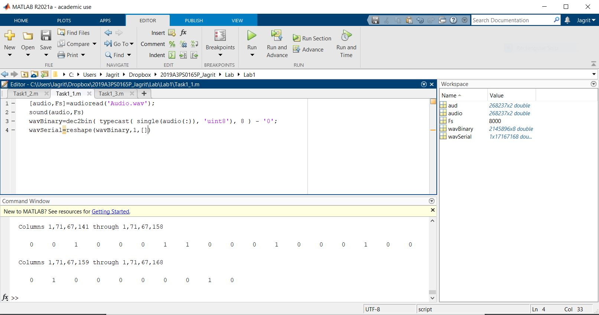

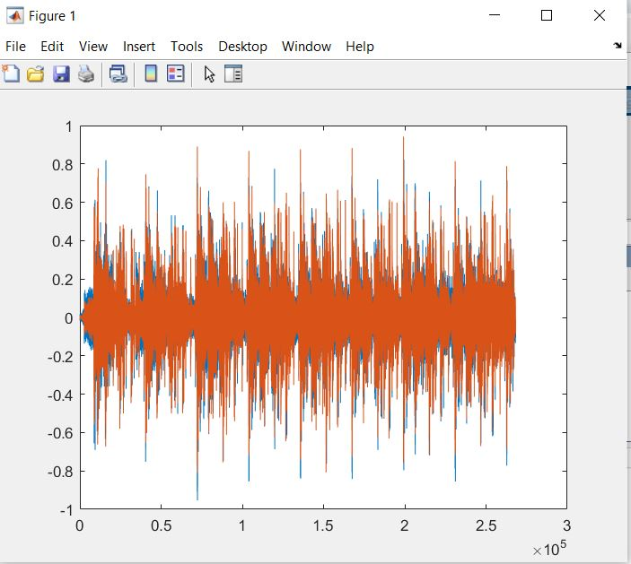

TASK 1.2 IMAGE FILE

clear all; close all; clc;

img = imread('Image.jpg');

image(img);

imstream = dec2bin(img)

imreshape = reshape(imstream,1,[])

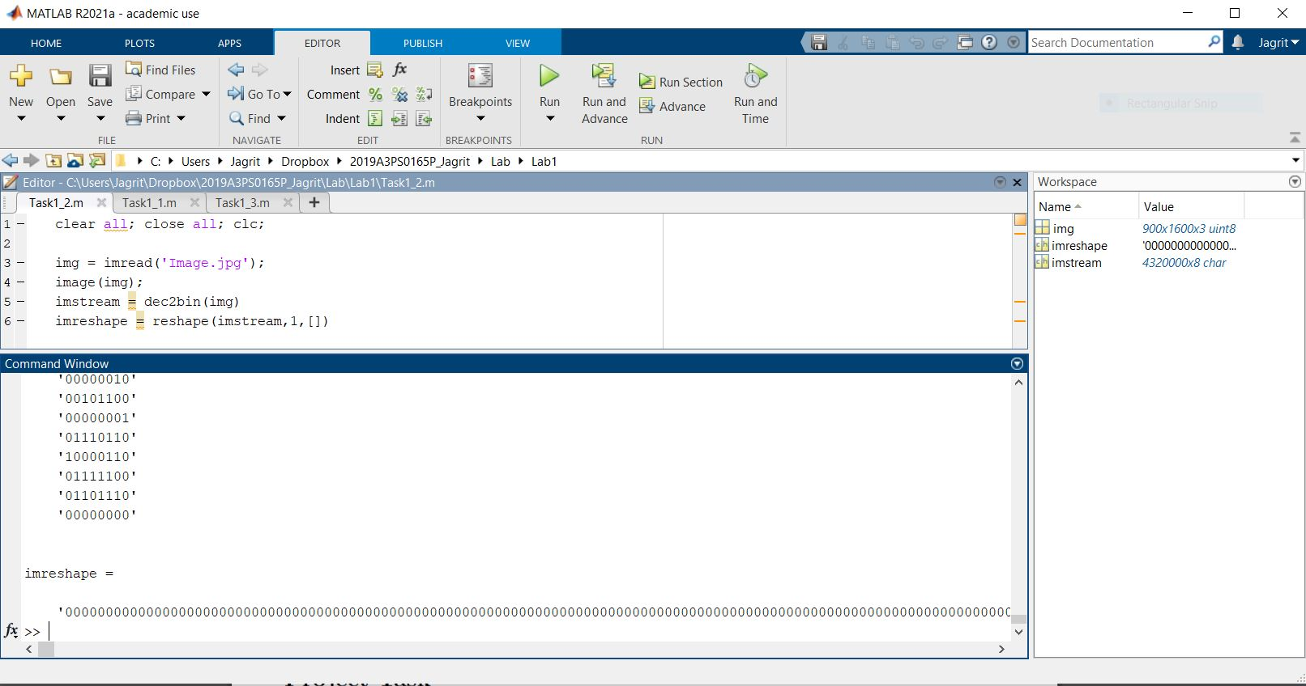

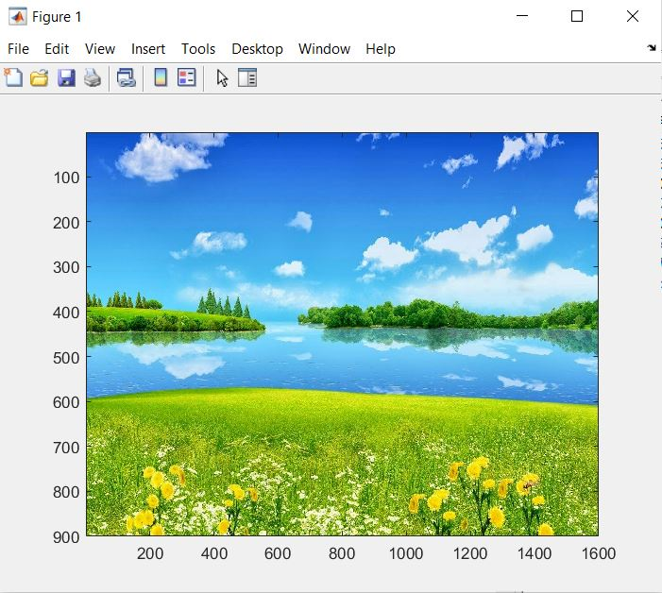

TASK 1.3 TEXT FILE

clear all; close all; clc;

fileToken = fopen('Text.txt');

textfile = fread(fileToken);

textstream = dec2bin(textfile)

textreshape = reshape(textstream, 1 ,[])

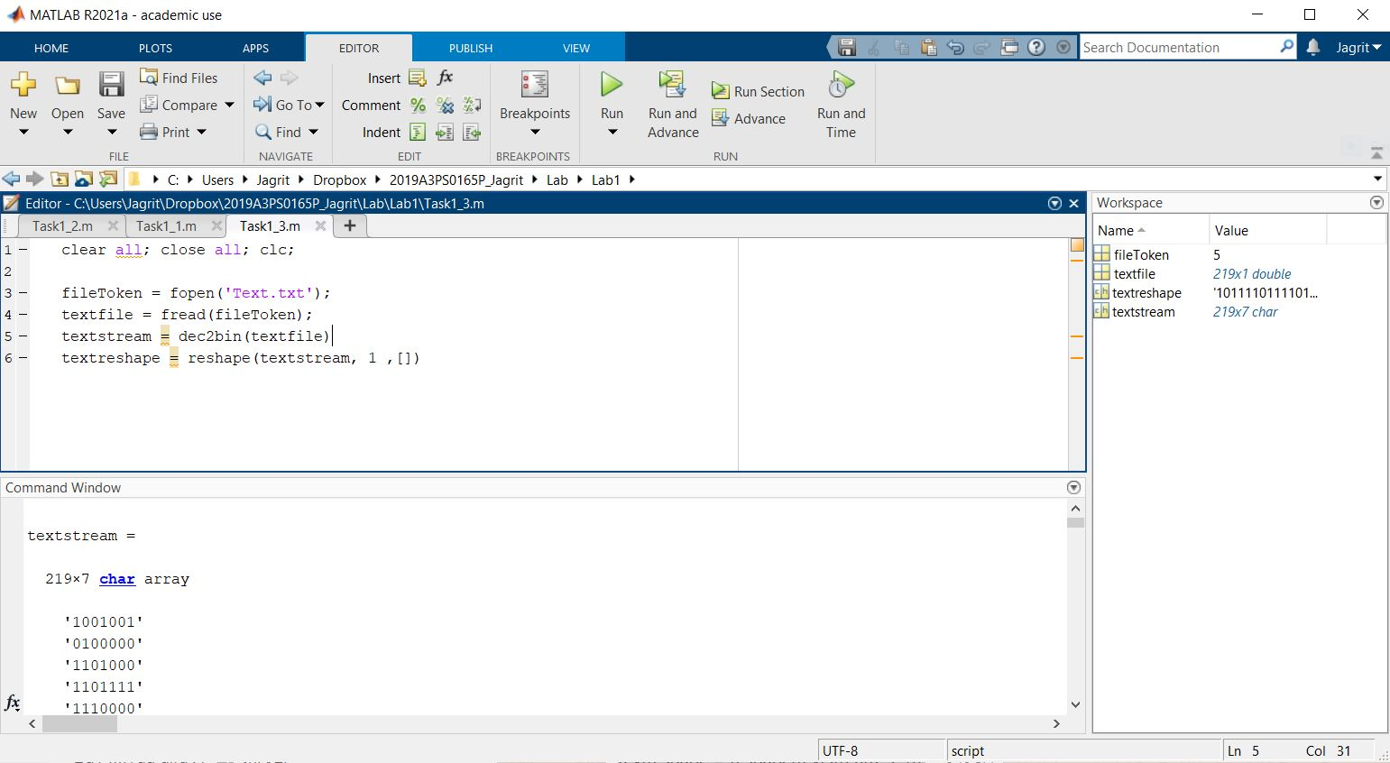

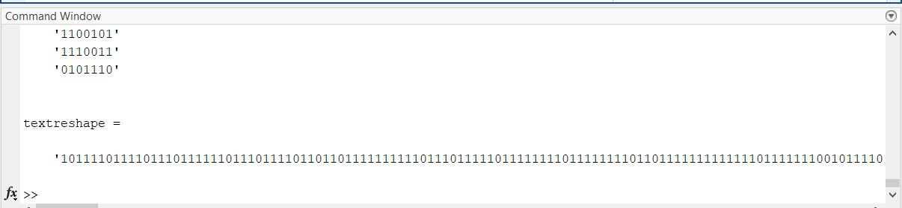

In all the three tasks, we can see that we convert the three types of signals to binary format.

Finally the binary signal is reshaped to fit into a single row (Serial Format).

PYTHON TASK 2 (SINE WAVE)

Last digit of ID = 5

import numpy as np  
import matplotlib.pyplot as plt  
  
# ID is 2019A3PS0165P  
N = 5  
fs = 1000   
t = np.arange(50)  
signal_m = np.sin(2 * np.pi * N * 10 * (t/fs))  
plt.title('Sinewave plot')  
  
plt.plot(t, signal_m)  
  
n = np.arange(50)  
dt = 0.05/50  
x = np.sin(2 * np.pi * 2 * 10 * n * dt)  
  
plt.stem(n, x)  
plt.show()

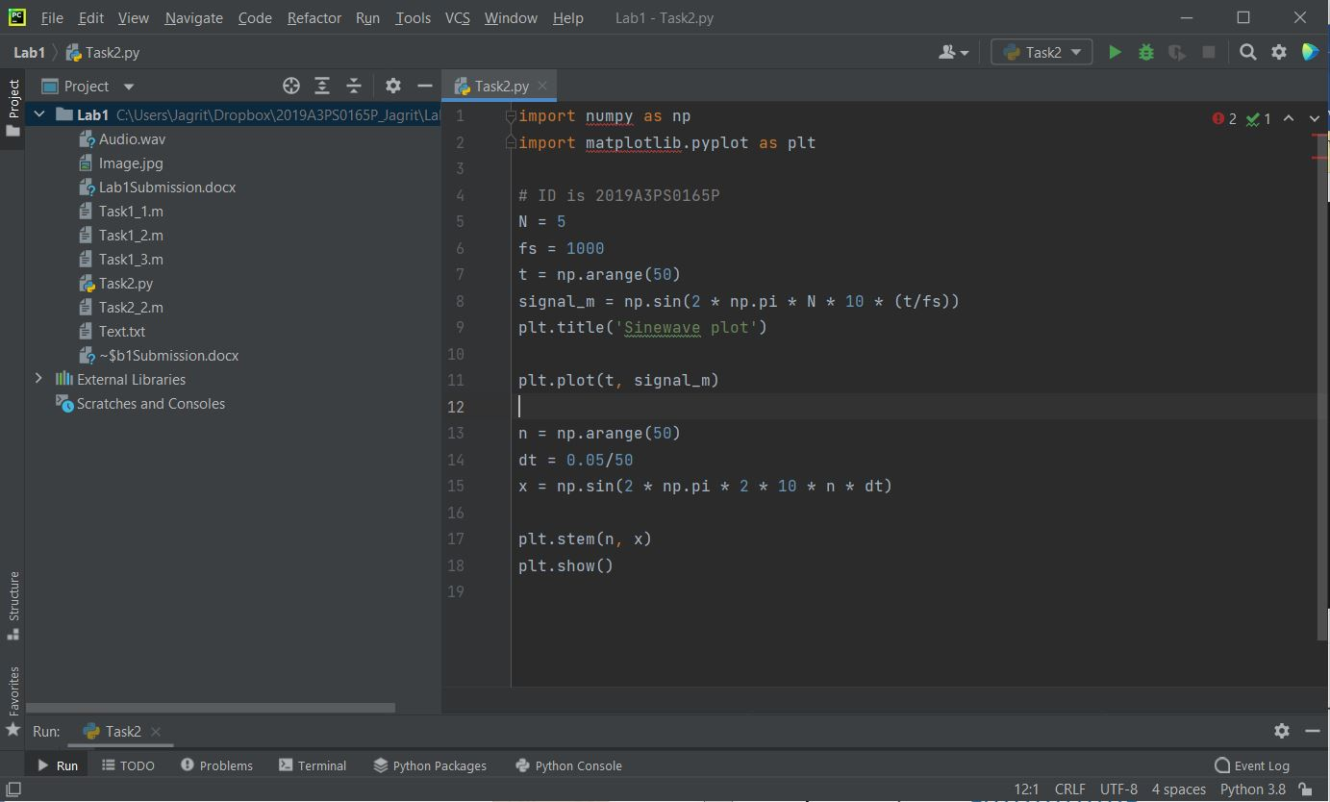

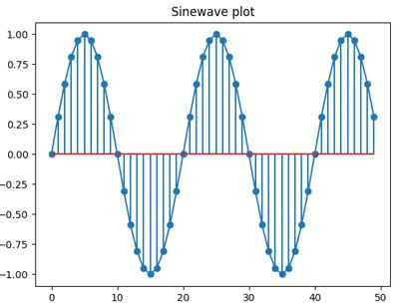

PROJECT TASK 2.2 (DONE IN MATLAB)

clc;

fs = 6000;

f1 = 450;

f2 = 650;

t = [0:1/fs:10];

wave1 = sin(2*pi*f1*t);

wave2 = sin(2*pi*f2*t);

outputwave = wave1 + wave2;

plot(outputwave)

sound(outputwave, fs);

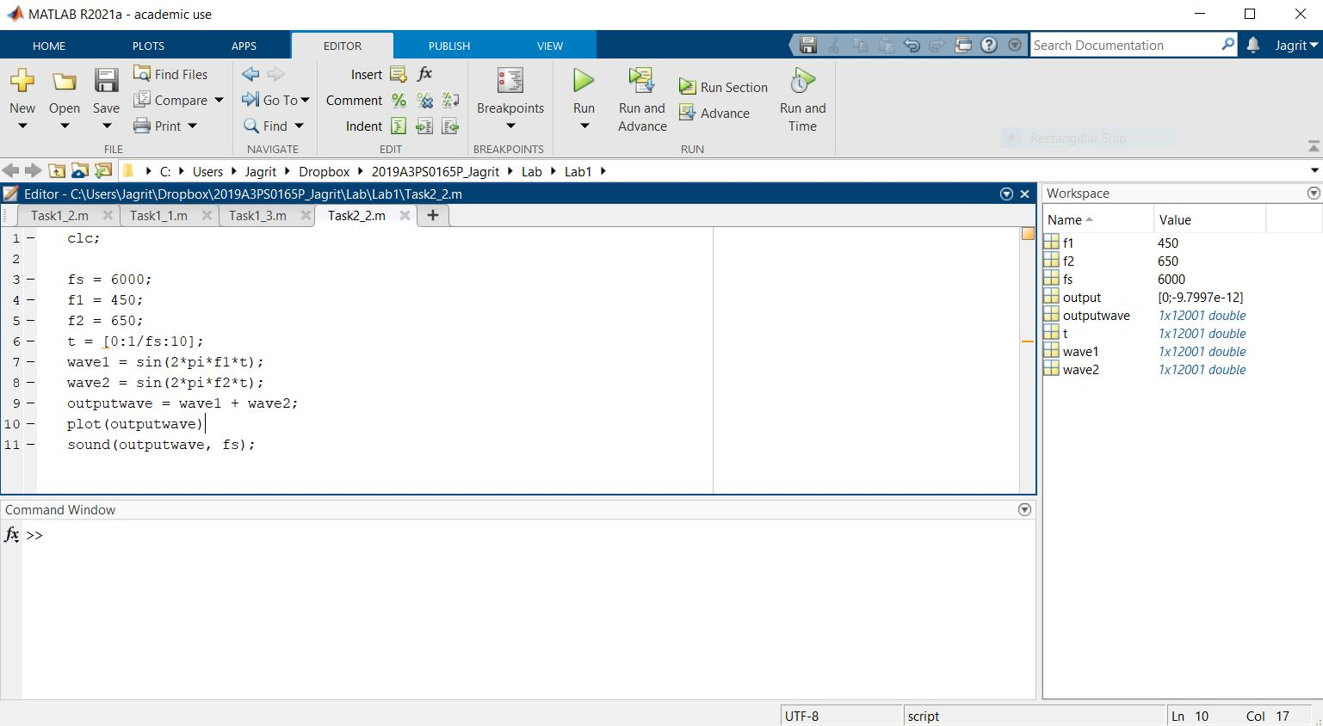

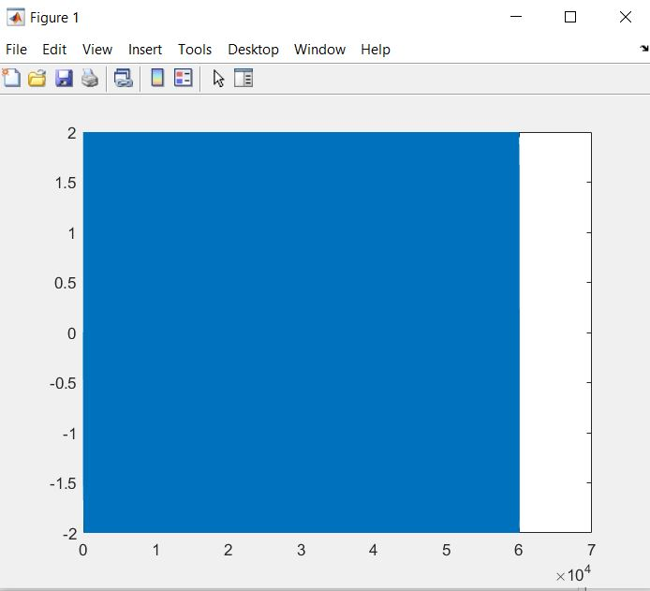

The continuous plot is seen due to the small sampling frequency and a large time axis being shown.